**Microprocessor and Computer Architecture**

**UE20CS252**

**4th Semester, Academic Year 2021-22**

|  |  |  |
| --- | --- | --- |
| Name: Nihal T M | SRN: PES2UG21CS333 | Section: F |

Date:08/03/2023

Week#____7_______ Program Number: ____1___

**Title of the Program**

Display hexadecimal digits [0-9,A-F] on the 8-segment display. Also display PES on the 8-segment display

**Include in your submission**

ARM Assembly Code(1)

Code:

@ up-counter

.text

.global start

begin:

mov r0,#0

mov r2,#0

again:

swi 0x202

cmp r0,#1

beq loop2

cmp r0,#2

beq loop1

b again

loop1:

mov r5,#16

ldr r1,=zero

back1:

ldrb r0,[r1]

swi 0x200

bl delay

add r1,r1,#1

sub r5,r5,#1

cmp r5,#0

bne back1

b again

loop2:

mov r5,#16

ldr r1,=F

back2:

ldrb r0,[r1]

swi 0x200

bl delay

sub r1,r1,#1

sub r5,r5,#1

cmp r5,#0

bne back2

b again

delay:

mov r4,#64000

loop3:

sub r4,r4,#1

cmp r4,#0

bge loop3

mov pc,lr

.data

zero:.byte 0b11101101

one:.byte 0b01100000

two:.byte 0b11001110

three:.byte 0b11101010

four:.byte 0b01100011

five:.byte 0b10101011

six:.byte 0b10101111

seven:.byte 0b11100000

eight:.byte 0b11101111

nine:.byte 0b11100011

A:.byte 0b11100111

B:.byte 0b00101111

C:.byte 0b10001101

D:.byte 0b01101110

E:.byte 0b10001111

F:.byte 0b10000111

Output Screen Shots (4)

1. up-counter:

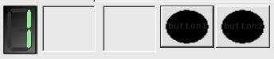

1. down-counter:

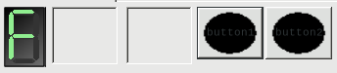

1. displaying P:

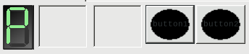

1. displaying E:

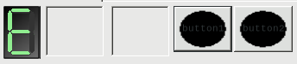

1. displaying S:

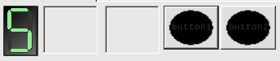

1. displaying U:

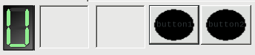

(upcounter/down counter screenshot)-1

letters P,E,S-3

Week#____7_______ Program Number: ____2___

**Title of the Program**

Move a string from RIGHT to LEFT on the LCD display panel. Display your name on the LCD Panel

**Include in your submission**

ARM Assembly Code(1)

.text

mov r0,#30

mov r1,#7

mov r7,#0

ldr r8,=num

ldr r8,[r8]

ldr r2,=str

loop:

swi 0x204

bl sum

cmp r0,#0

subne r0,r0,#1

swieq 0x11

b loop

sum:

cmp r7,r8

addne r7,r7,#1

bne sum

swi 0x206

mov r7,#0

mov pc,lr

.data

str:.asciz "NIHAL T M, PES2UG21CS333"

num:.word 15000

Output Screen Shot (1)

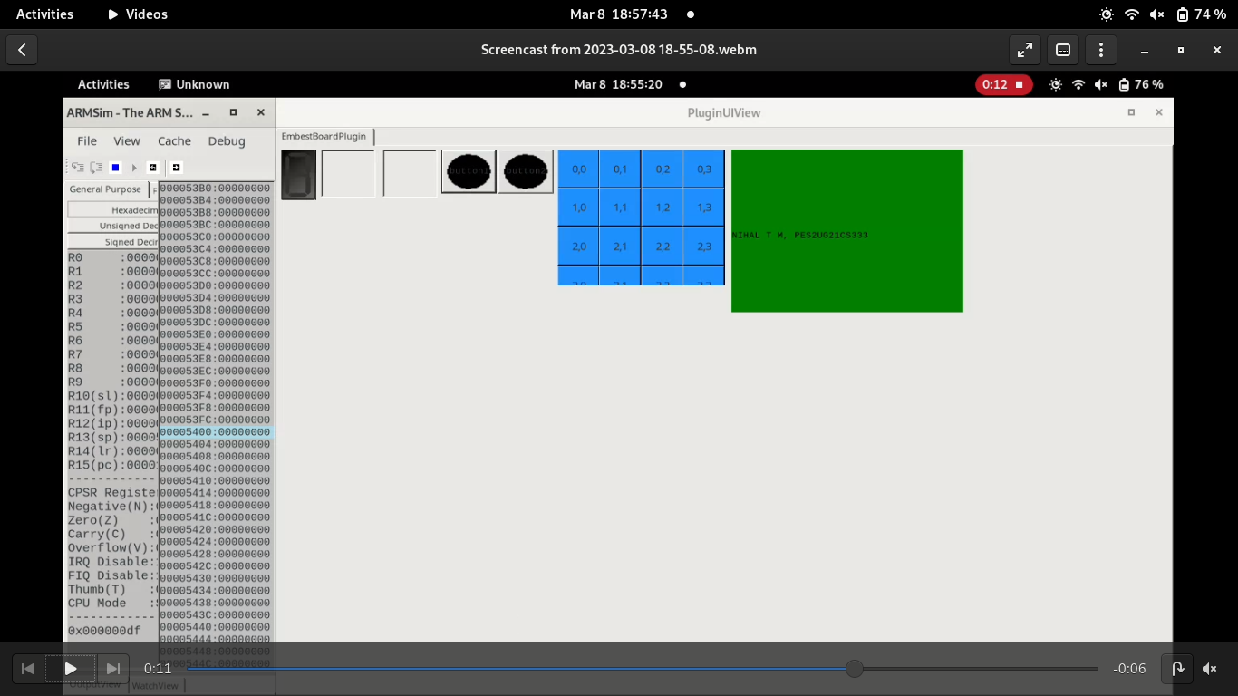

**Disclaimer:**

* The programs and output submitted is duly written, verified and executed by me.
* I have not copied from any of my peers nor from the external resource such as internet.
* If found plagiarized, I will abide with the disciplinary action of the University.

Signature:

Name: Nihal T M

SRN: PES2UG21CS333

Section: F

Date: 08/03/2023